Press Release for the 100th Birthday of the Painter Peter Janssen

On 29. March 2006 is the 100th birthday of Peter Janssen.

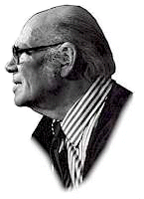

Peter Janssen was a painter and arts professor in Berlin from 1957 until 1971.

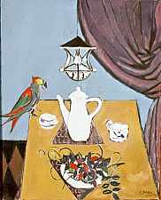 | 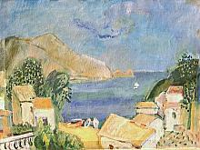 | 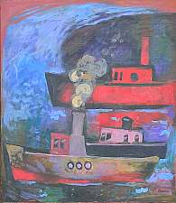

With a comprehensive exhibition on the internet his grandson Stephan Kotthaus has raised this virtual monument to commemorate this event.

Under www.janssenart.de you will find galleries with paintings, water colours, drawings and lithographs. In total more than 400 works are displayed in various ways i.e. still pictures, slideshows and videos.

Background information such as a biography and the history of the Janssen family artists will give you an interesting insight. Comments of art critics and media clips round off the picture.

In total an interesting presentation of a German artist and contemporary witness who belongs to the “Lost Generation“. These were artists whose careers were brutally interrupted by the Nazi Regime. Among them in 1935 Peter Janssen was prohibited to paint or exhibit his works. In 1944 he was deported to a concentration camp from which he managed to escape during a bomb raid.

This presentation is proof that the internet is an excellent media to preserve memories of art and artists and to keep them “alive”.

Stephan Kotthaus
Hoesbach, 15.02.2006

